


PUERTO RICO

UNIVERSIDAD DE PUERTO RICO, ESCUELA DE FARMACIA

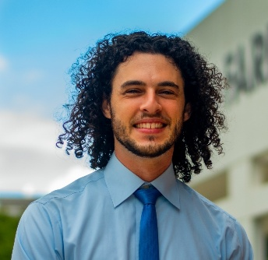
Kyle Melin
Kyle Melin es Profesor de Práctica Farmacéutica en la Escuela de Farmacia del Recinto de Ciencias Médicas de la Universidad de Puerto Rico. Es farmacéutico clínico en ejercicio e investigador en los campos de la farmacogenómica, los trastornos por uso de sustancias y la provisión de atención a minorías sexuales y de género. Cuenta con nombramientos conjuntos con la Alianza Nacional para la Salud Hispana como Senior Policy and Research Fellow, así como con el University College Dublin, donde se desempeña como profesor asociado visitante y becario Fulbright. kyle.melin@upr.edu
PROYECTOS
En preparación:
  - Pharmacogenomic Impact of CYP2D6 and CYP2C9 Variants on ADEs and Acute Hospital-Based Care in Hispanic/Latino Adults
En desarrollo
  - Association of Social Determinants of Health with Opioid Misuse Among Individuals with Common Psychiatric Conditions
  - Identification of risk and protective factors for co-occurrence of substance use disorders and major depressive disorder in people aged 18 years and older living in the United States.
  - Developing a personalized medicine community-based research agenda in Ireland.
  - Developing personalized medicine approaches to treating Opioid Use Disorder
  - Community pharmacy-based immunization programs.
PUBLICACIONES
  - Rodríguez Nazario I, Vilá LM, Melin K. Feasibility and acceptability of incorporating telemedicine into pharmacy services in the rheumatology clinics of the School of Medicine of the University of Puerto Rico. Am J Health Syst Pharm. 2025 Nov 12;(zxaf311):zxaf311.
  - Badillo-Salcedo J, Vélez-Jiménez GM, Rosado-Martínez EG, Melin K, Hernández-Agosto J. The relationship between Technology Use and Medication Access in older adults in Puerto Rico. Int J Environ Res Public Health. 2025 Oct 7;22(10):1534.
  - Bruxel EM, Rovaris DL, Belangero SI, Chavarría-Soley G, Cuellar-Barboza AB, Martínez-Magaña JJ, et al. Psychiatric genetics in the diverse landscape of Latin American populations. Nature Genetics. 2025 Apr 2;1–15.

  - Yang G, González P, Moneró M, Carrasquillo K, Renta JY, Hernandez-Suarez DF, et al. Discovery of ancestry-specific variants associated with clopidogrel response among Caribbean Hispanics. NPJ Genom Med. 2025 Mar 7;10(1):1–12.
  - Nuñez-Medina HJ, Monero M, Torres LM, Leal E, Gonzalez-Sepulveda L, Mayor ÁM, et al. Implementing a pharmacogenomic-driven algorithm to guide antiplatelet therapy among Caribbean Hispanics: a non-randomised clinical trial. BMJ Open. 2024 Sept 5;14(9):e084119.

